**Chinese Revolutionary Ballet**

**Summary**

Introduced to China in the 1920s, Western ballet evolved into a significant performance genre in modern and contemporary China. Its popularity grew in the twentieth century when political history, revolutionary wars, impact of Western cultures, and artistic visions of a new and modern state all played a significant role in the formation of Chinese revolutionary ballet. The revolutionary ballets took over this Western classical form and transformed its aesthetics, turning an elite spectacle into socialist realist portrayal of everyday life and its challenges.

**Importance to Modernism and Modernization**

The introduction of Western ballet into China can be traced to 1894, when the first Sino-Japanese war broke out. At that time, Yu Rongling (裕容龄) traveled to Japan with her father, a Manchu aristocratic diplomat of the Qing Court; she learned modern Japanese dance before pursuing a formal training in Western ballet in Paris. Yu’s teachers included Isadora Duncan, and Yu’s quick rise to stardom on the Western stage brought her into the Qing Court, from 1904 to 1907, as a lady-in-waiting to entertain Empress Dowager Cixi (慈禧太后), who developed an interest in Western modern dance. Yu also initiated a combination of Western modern dance with traditional Chinese folk dance, therefore paving the way for the future development of a unique choreography which blended Western and Chinese tradition.

One of the earliest dance pioneers to exert an impact on the Chinese society as a whole, however, was Wu Xiaobang (吴晓邦) who likewise travelled to Japan three times, from 1929 to 1936, to study modern dance, and established Xiaobang Dance School (晓邦舞踊学校), the first institution to teach modern dance, in Shanghai, in 1932. During the second Sino-Japanese war in the 1930s, Wu choreographed *The Song of the Guerrillas* (游击队员之歌) and *The March of the Volunteers* (义勇军进行曲) as part of the war mobilization effort and thus spread modern dance to broader audiences. Wu’s belief in dance as a social media in reflecting on immediate concerns in contemporary life and his achievement in popularizing modern dance paved the way for the future development of modern revolutionary ballet, which inherited Wu’s realist style and his experiments in combing Western modern dance with traditional Chinese choreographer.

Growing up in the West, Dai Ailian (戴爱莲) was among the earliest to bring her formal training in Western ballet (in London) to China in the 1940s. She choreographed and starred in a ballet performance entitled *Peace Dove* (和平鸽) in 1950, right after the founding of the People’s Republic of China (PRC) in 1949. Combining Western ballet with modern dance and Chinese folk traditions with an extraordinary feminine sensibility and a graceful figure, Dai created the beautiful character of a peace dove, who challenged a war monster (战争狂人); rescued by workers who rallied around her, she defeated the war monster’s attempt to ship ammunitions to the Korean war front (referring to Korean War, 1950-1951). With a clear anti-U.S. imperialist theme, the ballet ended with the dove’s celebration of world peace in front of Tiananmen Squire in Beijing with workers, peasants and soldiers, symbolizing new China’s successful struggle against imperialism and colonialism in a global context. Regarded as the first full length ballet created by a Chinese artist, *Peace Dove* laid a foundation for the future development of a revolutionary ballet in the PRC, which quickly transformed a Western genre into an indigenous art under state sponsorship.

The establishment of Beijing Dance School (北京舞蹈学校) in 1954 initiated the teaching of ballet as an academic discipline. The 1958 premier of *Swan Lake* (天鹅湖), directed by experts from the Soviet Union, starring Bai Shuxiang (白淑湘) and staged by Beijing Ballet School (北京芭蕾舞学校), marked a new era, in which ballet finally became a mature performance genre in China. The 1959 tour by Moscow State Ballet, starring Galina Sergeevna Ulanova (乌兰诺娃) in her lead roles in *Giselle* (吉赛尔) and *Swan Lake* (天鹅湖), on the occasion of celebrating the 10th anniversary of the founding of the PRC, illustrated the perfect combination of politics and art in modern China: The Soviet Union introduced to the Chinese audiences its cherished tradition in Western ballet as well as its highest achievement in ballet art on the socialist stage. By the same token, Moscow State Ballet’s performance of *The Road of Thunder* (雷电的道路), in the same tour, depicted two tragic lovers destroyed by apartheid in South Africa because of their different ethnic background; this ballet encouraged the Chinese ballet choreographers to explore their own civilization and contemporary life. Chinese artists therefore created a realist revolutionary ballet genre, which reflected on the concerns and issues in socialist China in its thematic concerns, thus treating art as life, as opposed to art as art. In this way, they skillfully explored Western ballet tradition to create an aesthetically satisfying dance form, while at the same time developing a socialist realist approach in terms of content, which remain “modern” and “revolutionary.” In 1964, at the peak of the Maoist socialist period, the first revolutionary modern ballet (革命现代芭蕾舞剧) *The Red Detachment of Women* (*Hongse Niangzi jun* 红色娘子军) premiered. This ballet has retained its classic status in the twentieth-first century. The ballet depicted the heroic woman soldiers who followed the Chinese Communist Party to liberate the oppressed people prior to the 1949 revolution. Based on the real-life experience of women veterans in the 1930s in Hainan province and deploying techniques and styles of traditional folk dance and Peking Opera, *The Red Detachment of Women* was immediately recognized as one of the best artistic achievements in the PRC in combining socialist realism with romanticism. The smooth transition of ballerina Bai Shuxiang from the first white swan of China (中国的第一只白天鹅) in 1958 to the protagonist of *The Red Detachment of Women* in 1964, symbolized the successful transformation of an elite Western form into a unique, popular Chinese style of ballet.

Equally successful was the premier of *White Haired Girl* (白毛女) by Shanghai Ballet School (上海舞蹈学校) in 1965. Sharing *The Red Detachment*’s theme of women’s liberation, however, *White Haired Girl* focused on the protagonist’s suffering before the Communist army rescued her from the “bitter sea of the old society” before 1949, as the official critics had claimed. According to the official media that promoted this ballet, it delivered a central message of how “the old society turned a human being into a ghost, and the new society turned the ghost back into a human being.” Such an official-line of interpretation also represented a familiar narrative in the numerous literary and performance texts, designated later as ‘the red classics’ in the first seventeen years of the PRC (1949 to 1966). Adapted from two award-winning films of the same titles in the early 1960s, these two “red classic ballets” demonstrated a productive cross-genre fertilization between Western and Chinese, modern and traditional, and elite and popular cultures.

During the radical years of the Cultural Revolution (1966-1976), these two ballets, along with five socialist-themed Peking Operas and one symphonic chorus, were revised and further promoted as model theater that replaced the so-called feudalist, bourgeois and revisionist art, which were targets of the Cultural Revolution. However, all of these eight model theatrical works included Western, bourgeois, and feudalist elements in creating a new artistic form which drew from traditional forms. Even the new, socialist content was not entirely new because it drew largely from the literary and artistic developments of the Republican period (1912 to 1949) and from the traditional culture; filality toward one’s parents in the traditional culture, for example, was smoothly transformed into one’s love for the local community of the poor, for the Communist Party which had supposedly fought for a better life of the poor and for the liberation of the Chinese nation as a whole. The premiers of the “revolutionary modern ballet” *The Song of the Yimeng Mountains* (沂蒙颂) in 1973 and *Son and Daughter of the Grassland* (草原儿女) in 1974 were publicized as additional achievements in model ballet during the Cultural Revolution because of the former’s depiction of people’s support for the past revolutionary war in Shandong province and the latter’s portrayal of contemporary life of ethnic minorities in inner-Mongolia in socialist China.

In the New Era (新时期, 1976-1989), Western ballets such as *Swan Lake* and *Giselle* shared the stage with modern Chinese classics in the first three decades of the twentieth century. Choreographer Jiang Zuhui (蒋祖慧), for example, utilized her training in the Soviet Union in the 1950s and her success in co-directing *The Red Detachment of Women* in order to choreograph *Blessing* (祝福, 1981), adapted from a short story by Lu Xun (鲁迅, 1924); in this ballet, Jiang depicted Xiang Linsao (祥林嫂), a poor widow sacrificed to a patriarchal society. This piece further enriched ballet convention with new ballet techniques previously not associated with ballet in order to express the innermost emotions of a traditional woman from rural China rather than focusing on actions and events. By the same token, Hu Rongrong (胡蓉蓉) successfully adapted Cao Yu’s (曹禺) *Thunderstorm* (雷雨, 1981), a classic May-Fourth spoken drama about a family tragedy in the tradition of Greek tragedy and Ibsen, originally published in 1934. Both Jiang and Hu developed Chinese revolutionary ballet by returning to modern literature from the beginning of the twentieth century; in doing so, they finally combined at least three modern revolutionary traditions: the critical realist tradition of the early twentieth century before the founding of the PRC period, the socialist realist and romantic cannons in the PRC period, and their Western predecessors, while experimenting with new choreography of Chinese characteristics that is at once popular and elite.

**Legacy**

In the 1990s when commercialism and the rise of a market economy challenged post-socialist theater, the restaging of *The Red Detachment of Women* in 1992 and in 1997 created new waves of a nostalgia for the “red classics”; the memory of the Maoist period, which was now considered “more equal” than post-Mao society, led to its renewed popularity and to commercial success. Decades after its premier as revolutionary modern ballet, *The Red Detachment* survived political turmoil, economic reform, ideological transformation from socialism to capitalism, and kept its crown status as a brilliant achievement of Chinese revolutionary ballet.

Xiaomei Chen

UC Davis

**List of Key Works**

*The Red Detachment of Women* (红色娘子军), 1964

*White Haired Girl* (白毛女), 1965

*The Song of the Yimeng Mountains* (沂蒙颂), 1973

*Son and Daughter of the Grassland* (草原儿女), 1974

**References and Further Reading**

Xiaomei Chen, *Acting the Righ*t Part: *Political Theater and Popular Drama in Contemporary China*. Honolulu: University of Hawaii Press, 2002.

Shuangbai Feng 冯双白, *Xin Zhongguo wudao shi* 新中国舞蹈史 (A history of Chinese dance: 1949-2000 (Changsha: Human meishu chubanshe), 2002.

_______, *Zhongguo xian dang dai wudao shiguang* 中国现当代舞蹈史纲 (A history of modern and contemporary dance in China). Beijing: Wenhua yishi chubanshe, 1999.

Rosemary A. Roberts, *Maoist Model Theatre: The Semiotics of Gender and Sexuality in the Chinese Cultural Revolution (1966-1976)*. Boston: Brill, 2011.

Zhirui Zou邹之瑞, *Xin Zhongguo baleiwu shi yanjiu*新中国芭蕾舞史研究 (A study of the ballet history in new China). Beijing: Qinghua Daxue chubanshe, 2013.

**Moving Image Material**

*The Red Detachment of Women,* [https:*//www.youtube.com/watch?v=ZHTPcs3lQPU*](https://www.youtube.com/watch?v=ZHTPcs3lQPU)

http://v.youku.com/v_show/id_XNjE5NTQ2NDQ4.html?f=19350870

*White Haired Girl* ( <https://www.youtube.com/watch?v=Ug-fhwXDMko>

*The Song of the Yimeng Mountains* https://www.youtube.com/watch?v=ZIdlO_kosOc

*Son and Daughter of the Grassland* <https://www.youtube.com/watch?v=dPHbkZl8I9k>

<http://www.zhuatieba.com/video/XMTMzMTM2MTMy>

http://www.56.com/u90/v_MTY1MzczOTE.html

**Paratextual Material**

Figure 1, Empress Dowager Cixi and Yu Rongling

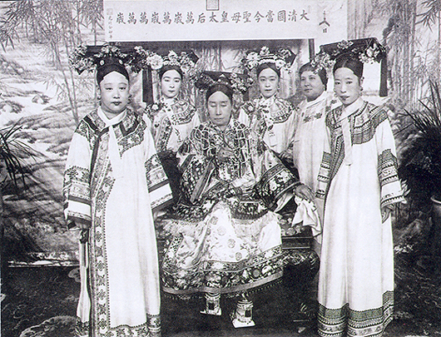

Figure 2, Yu Rongling （1882－1973) on Paris Stage

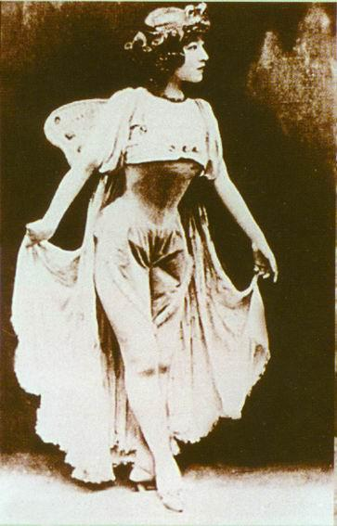

Figure 3, Yu Rongling Combined Western Ballet with Traditional Chinese Folk Dance

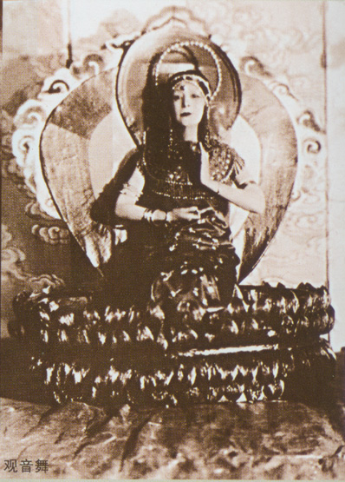

Figure 4, Dai Ailian in *Peac* e *Dove* (1950, The First PRC Ballet)

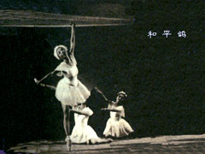

Figure 5, Dai Ailian in *Swan Lake*, Act II (1958)

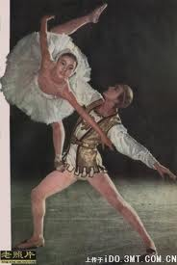

Figure 6, From he First “White Swan” to the First “Red Swan”: Dai Ailian in *Red Detachment of Woman* the First Revolutionary Ballet (1964).

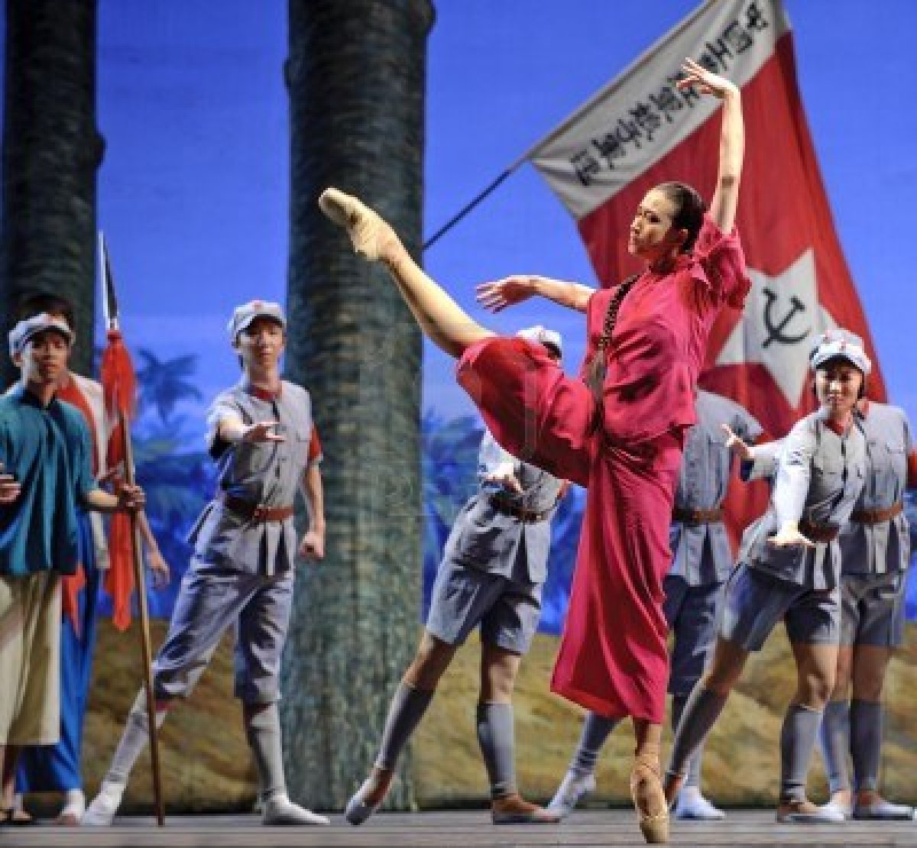

Mao Zedong Received the Cast of *Red Detachment of Woman* on October 8, 1964; The “Red Ballet” Toured in Japan, France, North Korea and was performed for Richard Nixon during his visit to China in 1972.

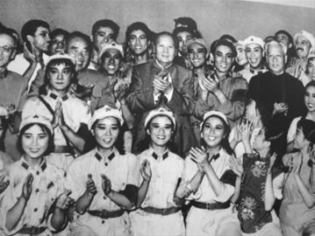

Figure 7, Posters of Model Theater Promoted During the Cultural Revolution (1966-1976) under the Leadership of Jiang Qing, Mao Zedong’s Wife, Who Promoted Model Theater.

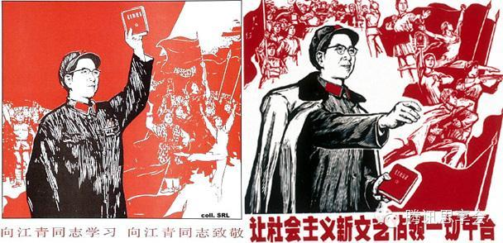

Figure 8，*White Haired Girl* (1965)

[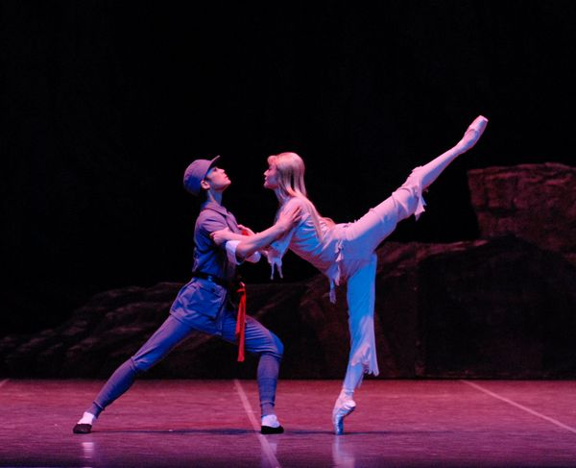](http://www.mask9.com/node/47325)

*Son and Daughter of the Grassland* (1974)

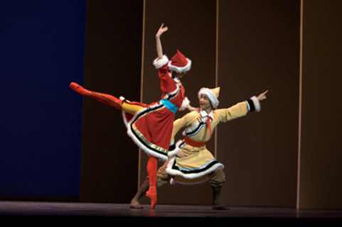

*The Song of the Yimeng Mountains* (1973)

